## Week 1

1. What is necessary for supervised machine learning?
   1. A model
   2. Labelled training data
   3. Learning from data
2. What decision boundary can logistic regression provide?
   1. Linear
3. What is the primary advantage of using multiple filters?
   1. This allows the model to look for subtypes of the classification.
4. What best describes transfer learning in the context of document analysis?
   1. Parameters at the bottom of the model are transferable across all people and documents, while the parameters at the top are different between individuals.
5. Given the following image of data classifications, what model would you choose?

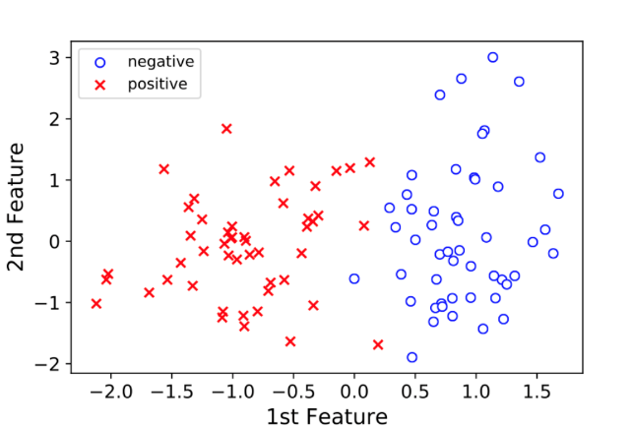

* 1. Logistic regression

1. What new feature did neural networks acquire in 2010?
   1. A new name: Deep Learning
2. Which of the following is convolved with layer 2 features, or sub-motifs?
   1. Layer 1 feature map
3. Which of the following gives the best conceptual meaning of convolution?
   1. Shifting a filter to every location in an image.
4. What does transfer learning mean in the context of medical imaging?
   1. Weights of convolutional layers learned from ImageNet transfer to medical images, so we only need learn new parameters at the top of the network.
5. What is the primary advantage of having a deep architecture?
   1. The model shares knowledge between motifs through their shared substructures.

## Week 2

## Week 3

## Week 4